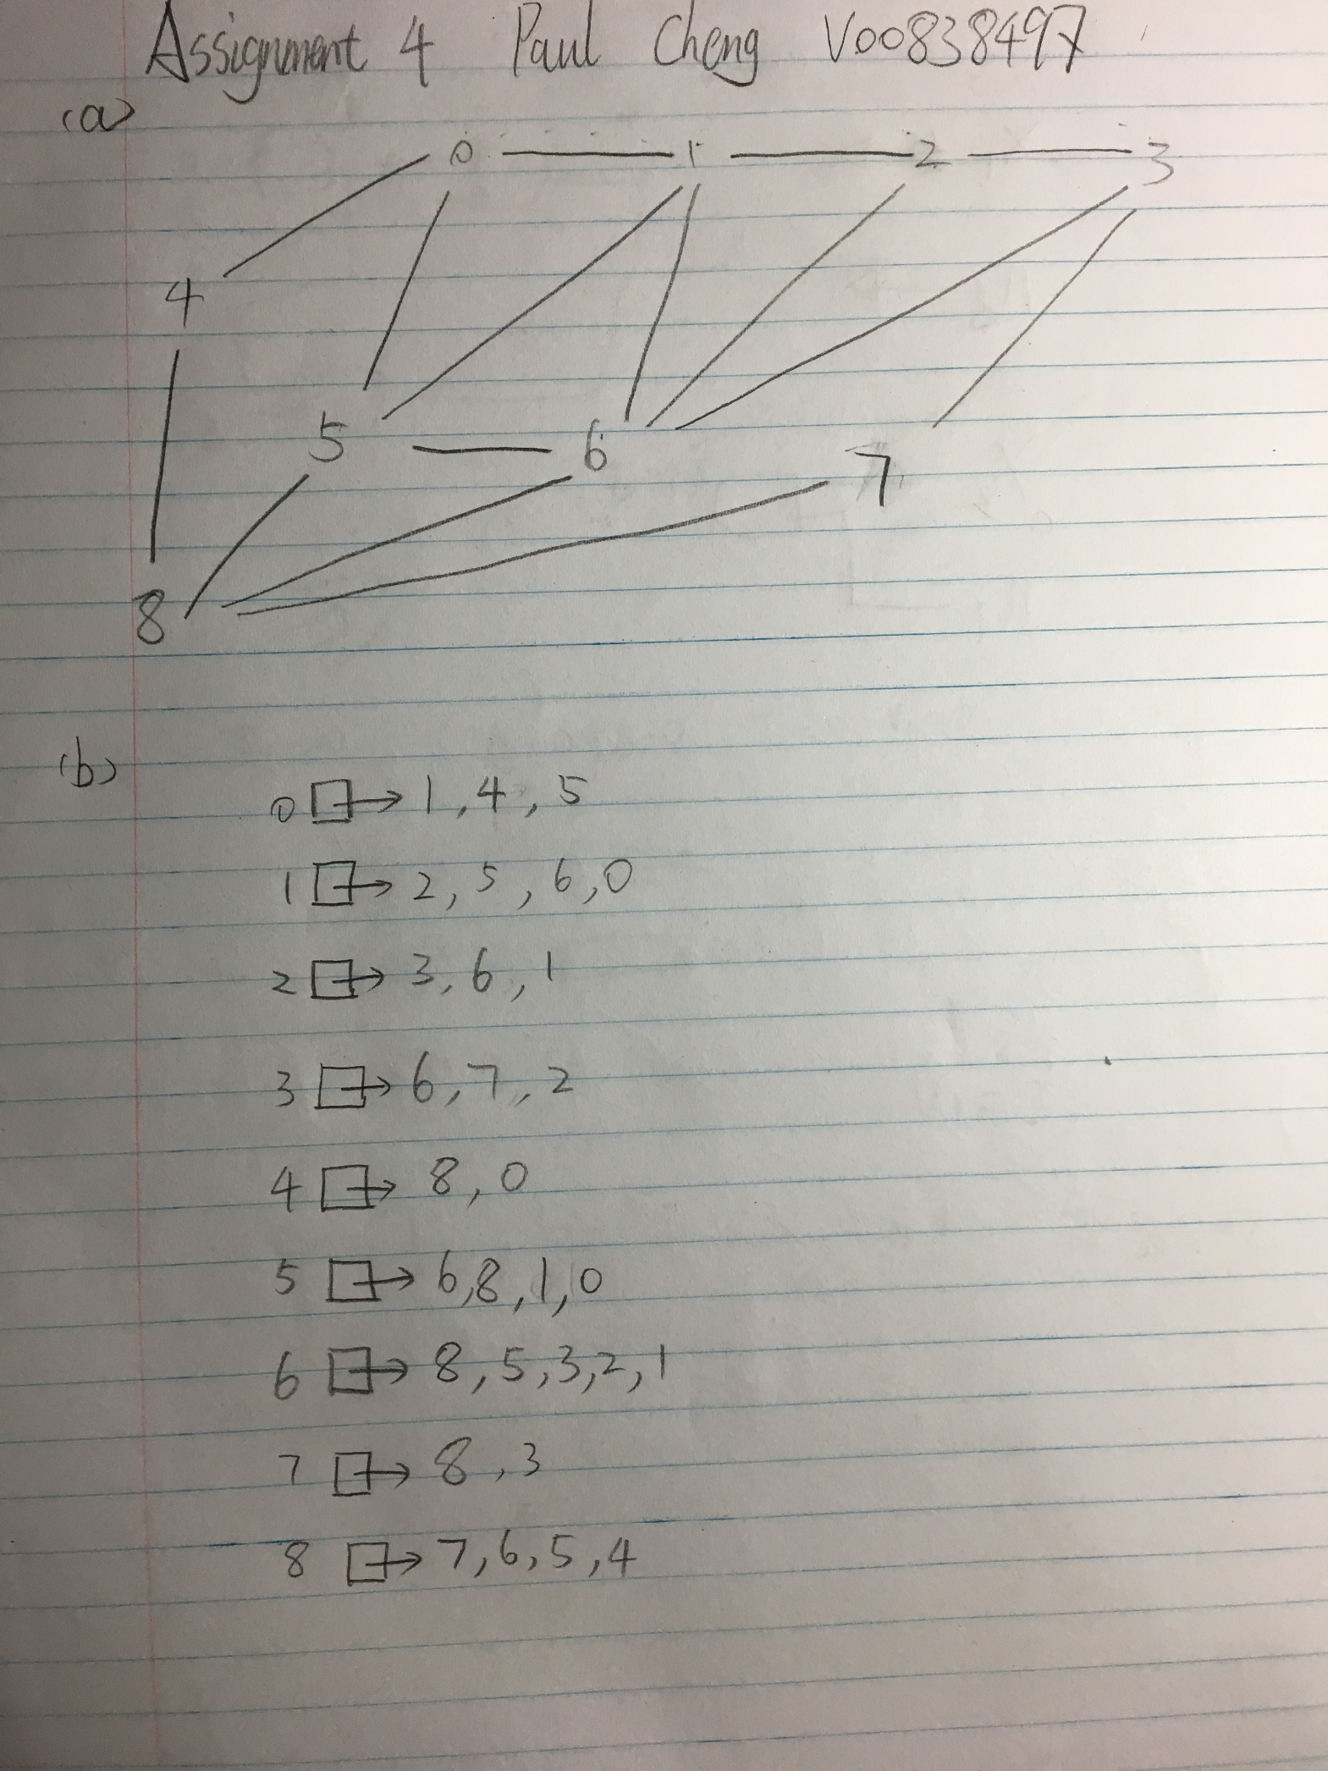

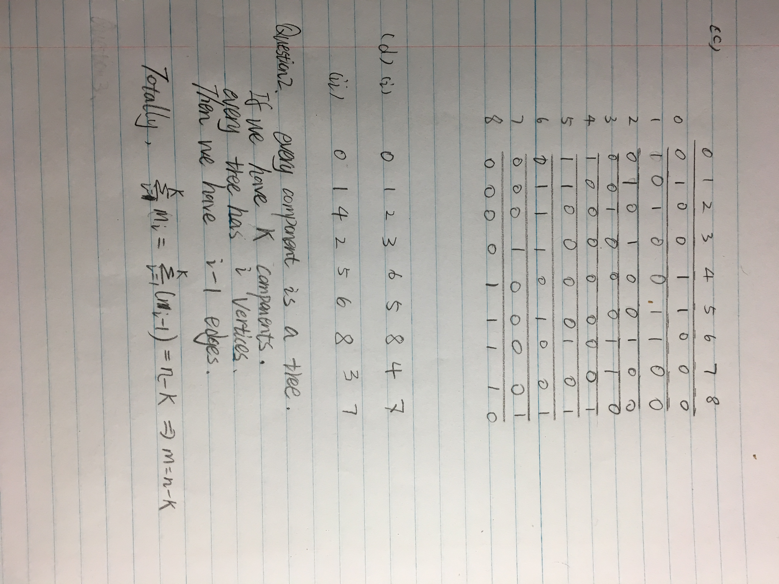

Question 3

(a)

Input: Graph G

Output: if graph has a unique topological order

Add vertices with no incoming edges into stack L1

While L1 is not empty do:

stack L2.push(L1.pop())

for all vertices w with an edge e from v to w do:

remove e from G;

if w has no other incoming edges except e do:

push w into L1

if G has edges left do:

return false

else

return true

(b)

(i) Yes, postorder will produce a topological order. Postorder will find all vertices with no incoming edges first and remove them from the tree, then do the same thing with the left vertices.

(ii)

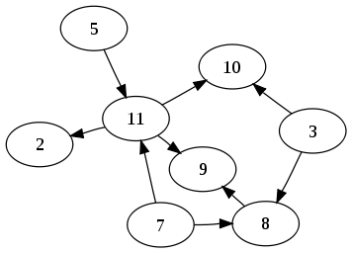

In this graph, it has topological order. When we do dfs with this graph, it has back edges.

Since if we start with 3,8,9 then we need to go back to 3.

Question 4

Input: a large network graph

Output: biggest completed subgraph

Reason: the question is asking to find largest group of people who are all friends with each other is to find the biggest completed graph in the network(Since everyone should be connected together, then it’s a completed grahp).